**The Smart Integrated Energy System using alternate Energy Sources**

**Problem Statement:** Electricity is the most important energy resource for the entire world and the development of mankind today has become totally dependent on electricity. One cannot imagine to live without electricity. On one hand the various conventional techniques for generation of electricity are from natural material like Coal, Petrol, Diezel etc. are rapidly getting exhausted and time will come very soon when these resources would get fully exhausted. The nuclear power is being now considered for power generation, but it has two major drawbacks namely the high cost of production and safety. It has been observed that there is a huge loss of electricity in the distribution network. So it is imperative to design a smart power distribution network for Alternative source of Energy.

**Problem Solution:** The purpose of this project is to present an idea to generate electricity by means of various alternate energy sources such as solar energy, wind energy, tidal energy, and geothermal energy and so on. The reason for considering all these methods of electricity generation as each of them when used individually, it has some drawback. For instance, if we consider only solar energy system, then sunlight, which is main source is available in the daytime only, also in different seasons the amount of sunlight available differs and will affect electricity generation. Hence it is best we use the integrated energy sources which would produce electricity. The electricity generation shall be done at small scale and the areas close to the user using Solar and Wind Energy. The backup system will be at off campus location. The backup will also be a renewable source of energy. The system will also involve the data coming from the National weather Service department, which will help the smart sensors to make decisions on which type of energy can consumer use at a given point of time the system will work with smart sensors which will make a switch between different energy sources.

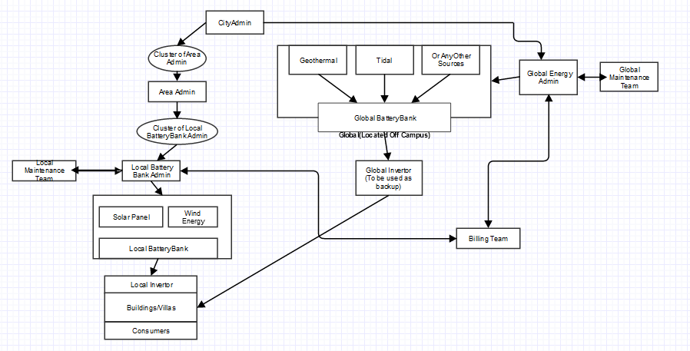

**Description:**

The Proposed Integrated System used alternate energy sources such as SOLAR Energy , WIND Energy which can be located on the top of each building/Campus. Backup power to be generated at Global level need not in campus and can be generated by means of alternate sources Geothermal energy, Tidal Energy and any other alternate energy source (Including solar or wind energy).

The next stage in this system is efficient Battery Bank which provides a means to store the energy generated as the electricity generated is in form of DC voltage. Thus we need two sets of Battery Bank one at local level in each campus or in building . The specification of Battery bank is dependent of requirement of power by each campus or building. The battery Bank is normally a series combination of number of Batteries.

At Global level also the electricity produced needs to be stored and since amount of power generated is of much higher quantum than that of Local or in campus/building level Batteries.

Since all the electrical and electronic appliances are driven by AC voltage, the DC voltage available in the form of stored energy in Battery Bank needs to be converted to AC voltage so that it can be made available to each household for actual consumption. This is done by means of Inverter which consists of an electronic circuit to convert DC to AC voltage. We need Inverter for each campus or Building . But for Global level we need inverter of much higher capacity.

The power generated by at Local level is distributed to each house by means of electrical cable network.

The power generated at Global level is used as backup power to all the campuses/buildings in the entire city by means of electrical conventional power distribution network.

The power generation at local level requires cost of initial installation which may be higher but once installed it is available almost free of cost( except minor cost for maintenance of system).

The Power generated at global level has to be done at commercial level hence to be paid by each user as per their utilization. Thus we need to set up a distribution network and also carry out billing exercise to that cost can be recovered from users. As there is huge investments to be made for power generation at global level, it must be supported by the government. The entire business model has to be worked out so that the project becomes economically feasible and self supporting.

**Smart Idea**: Whenever the Local Battery reaches below a particular threshold value, wherein consumers will not be able to get proper electricity. Since the Local Battery runs on Solar and Wind which are not a dependable source of energy. Hence the system will automatically switch from Local Invertor to Global Invertor and consumers shall be given an Alert or Information. When the Local Battery reaches above the threshold the system will switch back from Global source to Local and information will be given to consumers.

**The Billing System designed as follows:**

It considers two components, namely Initial Investment and running cost.

Initial Cost can be partly recovered by taking deposits from each user. The amount invested that cannot be recovered from deposits, shall be treated as initial investment whose interest and running cost can be together recovered from the users.

**The Roles**

**1.Consumers:** The person who consumes electricity. The Consumer will stay in the buildings or have his own villa. Consumers can check the energy consumption data of their house or office at any time. They can also view the bills at any given moment. Consumers will have access to the previous bills as well.

**2.Local Battery Admin**: The battery admin will be responsible for assisting groups of Buildings in a particular street. They will assist Consumers and consumers can ask for any type of help with respect to maintenance and Billing(regarding maintenance and one time installation charge).

**3. Local Maintenance Team:** The team will talk to Local Battery Admin they will provide address of the consumer and problem faced by them. The Maintenance team consist of many maintenance staff which assist consumers.

**4. Area Admin**: Looks into the administration of Local Area i.e. It will consist of Cluster of Local Battery Bank Admin. Role of Area Admin will look into staffing of Local Battery Bank Admin. This is similar to the Human Resources department. It will also maintain the Performance bonus of the Area Staff. They will also analyze various Business Analytic and provide a data dashboard for making decisions.

**5.Global Energy Admin**: The area will be responsible for providing consumers with the Global source of Energy system. It will look monitor the Global energy system. It will be also responsible for calling Maintenance Team in case of any failure to the system.

**6. Global Maintenance Team:** The team will be responsible for repairing the global energy systems. They will provide cost of maintenance to Global Energy Admin.

**7.Billing Team:** The billing team will be responsible for getting data from Local Battery banks and Global city admins. Since they will have data of consumers who have consumed the energy either Local/Global they will also maintain the costs of maintenance.

**8.City Admin:** The City admin will monitor the cluster of area admins and the global energy admin. It will be responsible for managing the areas and monitoring the global energy generation.

**Please Note:** The energy generation will be simulation. The application can be scaled further by making state admin, country admin or having a global role. The sensors will be authorized devices which will make switch between energy sources. The model is rough draft and is subject to change.